**QR Code Based Attendance System**

**1. INTRODUCTION:**

Nowadays, it is very important to finish the job fast, learn something new, get higher results as easy and efficiently as you can. Every sector, especially in the education process and in the business world, needs management systems that will enable them to have adequate control and management in the development of learning or work. Considering all these advantages and benefits, we thought that the process of education at the university, in particular, needs an online system to manage student attendance. Among others, regular attendance is a basic and most important criterion throughout the education system. Consequently, the student might lose the right to sit an exam if attendance criterion is not met. Moreover, if students exceed the number of allowed absences, they might also lose the right to sit final exams. Given that, the manual method which is currently used, give space for more calculation errors. We proposed and developed a better web-based system to help overcome such issues. It is fully responsive to mobile phones, tablets and various computer systems users. The proposed model provides data security and whole class or individual student attendance data can be accessed quickly and easily, moreover, the report is automatically generated by the professor. The purpose of the internet-based attendance system is to computerize the traditional way of registering attendance and to provide an easier and smarter way to track institutions attendance nowadays, based on a unique code for each professor and student known as QR code. At the beginning of each course, to confirm their attendance, users (professors and students) are required to scan their unique QR code assigned to them during or at the beginning of each lecture, using QR reading devices within the classrooms. Based on this, the lecture and student attendance record and other necessary data will be recorded. The system will help a lot in improving student attendance in particular courses they need to attend and will save a lot of time. This paper consists of three sections: the first part deals with the related papers; the second part details the proposed framework; and the last part details the implementation plan according to a case study conducted at University of Tetova – North Macedonia.

**1.1 Objective of the project:**

In higher education institutions, student participation in the classroom is directly related to their academic performance. However, the majority of student attendance registration is still conventionally done, which is tedious and time-consuming, especially for those courses that involve large numbers of students. Over the years, attendance management has been conducted manually at most of the universities. To overcome the manual attendance issues, we proposed and implemented a smart attendance system with the aim to encourage the potential use of the Quick Response (QR) code as a future attendance management system, to track and record student attendance in lectures and exercises for all relevant courses, as an aim of this paper.

**2. LITERATURE SURVEY:**

**“Attendance Management System (AMS) with fast track analysis,”**

Fast track analysis for Attendance Management System (AMS) is designed to facilitate the lecturer in monitoring student attendance during lecture session. Monitoring attendance is crucial especially for large group of students. Lecturers have difficulties to verify student's attendance during class and would take up some time. Error in key in the attendance into the system is also likely when transferring the attendance into the main system, with no way to trace the mistakes once the class is over. Late comers would be overlooked due to recording on the time they join the classes. Hence, a new system was innovated applying simple mechanism which consists of RFID data logger and data analysis using ASP.net. The system is portable and quick to verify attendances within 5 minutes regardless, of the size of the class.

**“Effective and efficient attendance tracking system using secret code,”**

Students' attendance taking and tracking are important in order to monitor students' performance in class. More often than not, students' performance is closely related to their attendance. Good attendance usually leads to good performance and vice versa. Therefore, any problems related to students' attendance should be identified as early as possible so that appropriate measures can be taken to address them. However, tracking students' attendance, especially if done manually, can be tedious and time consuming, especially for classes will large number of students. Not to mention issues related to attendance taking such as signatures forgery where other students are signing on behalf of their absence friends. To address this issue, a unique and secure attendance tracking system is proposed. The system automates most of the steps involved in tracking students' attendance. To address the issue of signature forgery, secret code using MD5 hashing algorithm is implemented as part of the system so that each student will be given a unique code each day to be used for signing attendance. Implementation of the system shows that the time taken to track students' attendance using this system can be significantly reduced and the secret code is able to prevent signature forgery amongst students.

**“Attendance Management System,”**

In today's era regardless of the field of study or preference for defining data (quantitative, qualitative), accurate data collection is essential for maintaining the integrity of research. Selection of appropriate method and the device used for data acquisition reduces chances of errors occurring. Proposed system has a small handy hardware, a remote server and software components for acquisition of data manually or from sensors electronically. It could be used in doing survey's, closed loop control monitoring systems in industries, hospitals, attendance management system of schools and colleges etc. This paper presents a design and framework for taking attendance in schools and colleges, for making troublesome process of taking and compiling of attendance simple and efficient. As its targeted users are educational institutes where there is a requirement of affordable, user friendly, portable, energy efficient and secure automated system. Hence this prototype provides an amalgamated solution for replacing existing conventional attendance system with embedded attendance system. Main advantages are its very low cost, small size, efficient with low energy consumption.

**“QR Code Based Smart Attendance System”,**

In this era of technology smart phones play a significant role in our day to day life. Nowadays smart phones can solve most of the problem very quickly and easily. It has made life of every person simple and easier with different social app, commercial app, problem solving app, app for education and marketing etc. Followed by the technology the paper purposed a system that will handle a problem for recording the attendance. The proposed system is a couple of two applications, one for generating the QR Code by entering the student details and second application for taking the attendance and generating the attendance in CSV or XLS format. The teacher will need to scan the QR code of the particular student in order to confirm their attendance. The paper discusses how the system verifies student identity to eliminate false registrations. The system deals with the management and evaluation of attendance of all students. The student QR code will be provided to professor for taking their attendance. The professor handling the subjects is responsible to mark the attendance for all students of the group or class. The attendance will be marked as 0 and 1, 0 for absent and 1 for present in the database of the particular student row in the table. The student attendance reports will be generated in CSV and XLS sheet for further use.

**“A Students Attendance System Using QR Code”**

Smartphones are becoming more preferred companions to users than desktops or notebooks. Knowing that smartphones are most popular with users at the age around 26, using smartphones to speed up the process of taking attendance by university instructors would save lecturing time and hence enhance the educational process. This paper proposes a system that is based on a QR code, which is being displayed for students during or at the beginning of each lecture. The students will need to scan the code in order to confirm their attendance. The paper explains the high level implementation details of the proposed system. It also discusses how the system verifies student identity to eliminate false registrations.

**3. SYSTEM ANALYSIS**

**3.1 Existing System**

There are quite a number of previous researches in the field of computer science developed students attendance tracking system to improve record taking in class using different technologies. For example, RFID or near field communication (NFC) technology An example of application that Jainetal has developed is a desktop application in which a list of all registered students in a particular course is displayed when the class commences. Attendance is registered by clicking off a checkbox next to student’s name that are present, and then for marking their presence a register button is clicked.

**Disadvantages of Existing System:**

* Less Accuracy

**3.2 Proposed System**

The proposed system by authors on aims to record all student participation based on the generated unique QR code of each course for each class day. The instructors, in turn, copy this QR code and paste it on the first slide to be displayed in the lecture. If the instructor policy is to allow late students in his class and would like to mark them as present or late, then the QR code should also be copied on one of the four corners of as many slides as the instructor wishes. When the students are in class, the first thing that should be done is to pull out their smart phones, open the Mobile Module, and scan the QR code, then the Server Module runs an identity check on the registered students. These days it is required to keep up with the latest technologies, especially in the field of education. Educational institutions have been looking for ways to enhance the educational process using the latest technologies. Seeing as everything moves towards digitalization, we think that this system is pretty much necessary for the University. In this paper, we have described a proposed system that incorporates QR codes and devices connected to internet in taking student attendance. This study shows that the QR code, a multi-faceted and popular feature of smart devices, can be used as an efficient method of recording attendance, replacing the old, traditional way of calling name lists in class The proposed system provides better security than the traditional methods, including eliminating chances of students signing up for others who may not be present. Even though similar platforms are already developed, we believe that the proposed platform will be more attractive for several reasons: It has a great advantage, among all types of code scanning technology; the QR Code attendance system is the most accurate and efficient method of maintaining attendance in a database and controlling it from any intelligent device rather than wasting paper.

**Advantages of Proposed System:**

* High Accuracy.

**Modules Information:**

To implement this project author has designed following modules

1. Admin module: admin can login to application by using username and password as ‘admin’ and ‘admin’ and then can ADD New Employee Details and then application will generate QR CODE on EMPLOYEE ID and then admin can download that image and give to employee and employee can show that image to QR CODE scanner to mark attendance. Admin can view all employee details and then can view employee attendance by using start and end date.
2. Employee Login Module: employee can login to system by using his ID and can view his attendance from start and end date selection
3. QR CODE WEBCAM SCANNER: employee has to show his QR CODE image from his mobile to webcam and then webcam will read QR CODE and mark attendance. Only one attendance for each employee for each day will be marked.

**FUNCTIONAL REQUIREMENTS:**

**SOFTWARE REQIREMENTS:**

**System Atributes:**

1. Username

**Data base Requirements:**

No need

**USECASE:**

* Use cases - Use cases describe the interaction between the system and external users that leads to achieving particular goals.
* Each use case includes main elements:

1. Admin module
2. Employee Login Module
3. QR CODE WEBCAM SCANNER

**User Stories:**employee can view all present days date and current payable salary

**Work down Structure:**

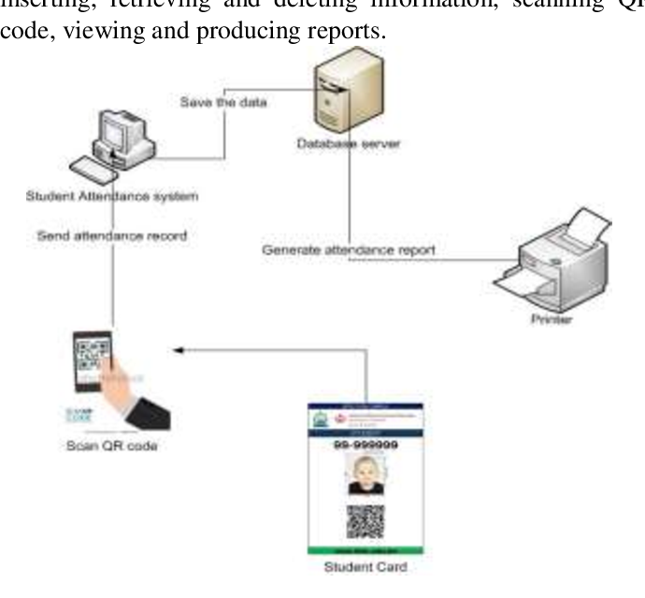

**Prototype:**

python 3.7.0 or 3.7.4

opencv-python==4.5.1.48

keras==2.3.1

tensorflow==1.14.0

protobuf==3.16.0

h5py==2.10.0

sklearn-extensions==0.0.2

scikit-learn==0.22.2.post1

Numpy

Pandas

**Models and Diagrams:**

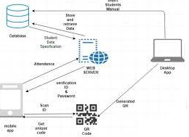

**NON-FUNCTIONAL REQUIREMENT:**

**Usability:**  Usability is a quality attribute that assesses how easy user interfaces are to use. The word "usability" also refers to methods for improving ease-of-use during the design process.(how it was handle entire project easy)

**Security:**the quality or state of being secure: such as. a : freedom from danger : safety. b : freedom from fear or anxiety. c : freedom from the prospect of being laid off job security.

**Readability:** Readability is the ease with which a reader can understand a written text.

**Performance**: the execution of an action. : something accomplished : deed, feat. : the fulfillment of a claim, promise, or request : implementation. 3. : the action of representing a character in a play.

**Availability**: the quality or state of being available trying to improve the availability of affordable housing. 2 : an available person or thing.

**Scalability**: Scalability is the measure of a system's ability to increase or decrease in performance and cost in response to changes in application and system processing demands.

**3.3. PROCESS MODEL USED WITH JUSTIFICATION**

**SDLC (Umbrella Model):**

**Umbrella Activity**

**Umbrella Activity**

**Umbrella Activity**

1. Feasibility Study
2. TEAM FORMATION
3. Project Specification PREPARATION

Business Requirement Documentation

ANALYSIS & DESIGN

CODE

UNIT TEST

DOCUMENT CONTROL

ASSESSMENT

TRAINING

INTEGRATION & SYSTEM TESTING

DELIVERY/INSTALLATION

ACCEPTANCE TEST

Requirements Gathering

SDLC is nothing but Software Development Life Cycle. It is a standard which is used by software industry to develop good software.

**Stages in SDLC:**

* Requirement Gathering
* Analysis
* Designing
* Coding
* Testing
* Maintenance

**Requirements Gatheringstage:**

The requirements gathering process takes as its input the goals identified in the high-level requirements section of the project plan. Each goal will be refined into a set of one or more requirements. These requirements define the major functions of the intended application, define operational data areas and reference data areas, and define the initial data entities. Major functions include critical processes to be managed, as well as mission critical inputs, outputs and reports. A user class hierarchy is developed and associated with these major functions, data areas, and data entities. Each of these definitions is termed a Requirement. Requirements are identified by unique requirement identifiers and, at minimum, contain a requirement title and textual description.

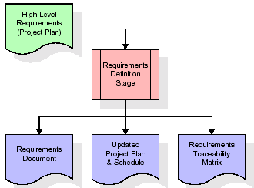

These requirements are fully described in the primary deliverables for this stage: the Requirements Document and the Requirements Traceability Matrix (RTM). The requirements document contains complete descriptions of each requirement, including diagrams and references to external documents as necessary. Note that detailed listings of database tables and fields are *not* included in the requirements document.

The title of each requirement is also placed into the first version of the RTM, along with the title of each goal from the project plan. The purpose of the RTM is to show that the product components developed during each stage of the software development lifecycle are formally connected to the components developed in prior stages.

In the requirements stage, the RTM consists of a list of high-level requirements, or goals, by title, with a listing of associated requirements for each goal, listed by requirement title. In this hierarchical listing, the RTM shows that each requirement developed during this stage is formally linked to a specific product goal. In this format, each requirement can be traced to a specific product goal, hence the term requirements traceability.

The outputs of the requirements definition stage include the requirements document, the RTM, and an updated project plan.

* Feasibility study is all about identification of problems in a project.
* No. of staff required to handle a project is represented as Team Formation, in this case only modules are individual tasks will be assigned to employees who are working for that project.
* Project Specifications are all about representing of various possible inputs submitting to the server and corresponding outputs along with reports maintained by administrator.

**Analysis Stage:**

The planning stage establishes a bird's eye view of the intended software product, and uses this to establish the basic project structure, evaluate feasibility and risks associated with the project, and describe appropriate management and technical approaches.

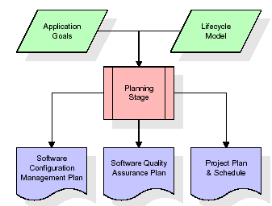

The most critical section of the project plan is a listing of high-level product requirements, also referred to as goals. All of the software product requirements to be developed during the requirements definition stage flow from one or more of these goals. The minimum information for each goal consists of a title and textual description, although additional information and references to external documents may be included. The outputs of the project planning stage are the configuration management plan, the quality assurance plan, and the project plan and schedule, with a detailed listing of scheduled activities for the upcoming Requirements stage, and high level estimates of effort for the out stages.

**Designing Stage:**

The design stage takes as its initial input the requirements identified in the approved requirements document. For each requirement, a set of one or more design elements will be produced as a result of interviews, workshops, and/or prototype efforts. Design elements describe the desired software features in detail, and generally include functional hierarchy diagrams, screen layout diagrams, tables of business rules, business process diagrams, pseudo code, and a complete entity-relationship diagram with a full data dictionary. These design elements are intended to describe the software in sufficient detail that skilled programmers may develop the software with minimal additional input.

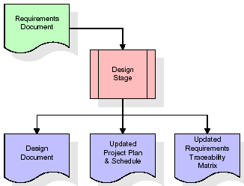  
When the design document is finalized and accepted, the RTM is updated to show that each design element is formally associated with a specific requirement. The outputs of the design stage are the design document, an updated RTM, and an updated project plan.

**Development (Coding) Stage:**

The development stage takes as its primary input the design elements described in the approved design document. For each design element, a set of one or more software artifacts will be produced. Software artifacts include but are not limited to menus, dialogs, and data management forms, data reporting formats, and specialized procedures and functions. Appropriate test cases will be developed for each set of functionally related software artifacts, and an online help system will be developed to guide users in their interactions with the software.

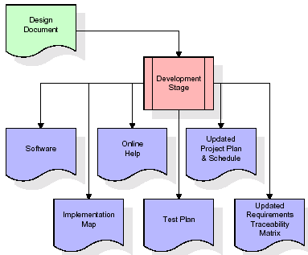

The RTM will be updated to show that each developed artifact is linked to a specific design element, and that each developed artifact has one or more corresponding test case items. At this point, the RTM is in its final configuration. The outputs of the development stage include a fully functional set of software that satisfies the requirements and design elements previously documented, an online help system that describes the operation of the software, an implementation map that identifies the primary code entry points for all major system functions, a test plan that describes the test cases to be used to validate the correctness and completeness of the software, an updated RTM, and an updated project plan.

**Integration & Test Stage:**

During the integration and test stage, the software artifacts, online help, and test data are migrated from the development environment to a separate test environment. At this point, all test cases are run to verify the correctness and completeness of the software. Successful execution of the test suite confirms a robust and complete migration capability. During this stage, reference data is finalized for production use and production users are identified and linked to their appropriate roles. The final reference data (or links to reference data source files) and production user list are compiled into the Production Initiation Plan.

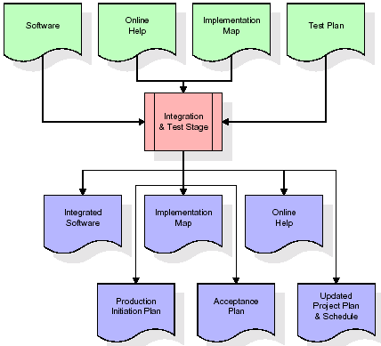

The outputs of the integration and test stage include an integrated set of software, an online help system, an implementation map, a production initiation plan that describes reference data and production users, an acceptance plan which contains the final suite of test cases, and an updated project plan.

* **Installation & Acceptance Test:**

During the installation and acceptance stage, the software artifacts, online help, and initial production data are loa ded onto the production server. At this point, all test cases are run to verify the correctness and completeness of the software. Successful execution of the test suite is a prerequisite to acceptance of the software by the customer.

After customer personnel have verified that the initial production data load is correct and the test suite has been executed with satisfactory results, the customer formally accepts the delivery of the software.

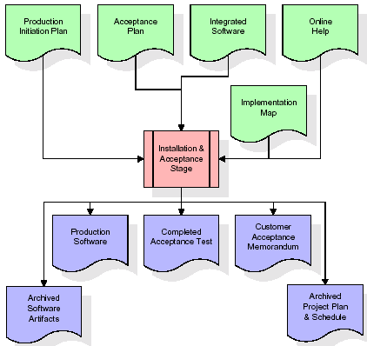

The primary outputs of the installation and acceptance stage include a production application, a completed acceptance test suite, and a memorandum of customer acceptance of the software. Finally, the PDR enters the last of the actual labor data into the project schedule and locks the project as a permanent project record. At this point the PDR "locks" the project by archiving all software items, the implementation map, the source code, and the documentation for future reference.

**Maintenance:**

Outer rectangle represents maintenance of a project, Maintenance team will start with requirement study, understanding of documentation later employees will be assigned work and they will undergo training on that particular assigned category. For this life cycle there is no end, it will be continued so on like an umbrella (no ending point to umbrella sticks).

**3.4. Software Requirement Specification**

**3.4.1. Overall Description**

A Software Requirements Specification (SRS) – a [requirements specification](http://en.wikipedia.org/wiki/Requirements_specification) for a [software system](http://en.wikipedia.org/wiki/Software_system) is a complete description of the behavior of a system to be developed. It includes a set of [use cases](http://en.wikipedia.org/wiki/Use_case) that describe all the interactions the users will have with the software. In addition to use cases, the SRS also contains non-functional requirements. [Nonfunctional requirements](http://en.wikipedia.org/wiki/Non-functional_requirements) are requirements which impose constraints on the design or implementation (such as [performance engineering](http://en.wikipedia.org/wiki/Performance_engineering) requirements, [quality](http://en.wikipedia.org/wiki/Quality_%28business%29) standards, or design constraints).

System requirements specification: A structured collection of information that embodies the requirements of a system. A [business analyst](http://en.wikipedia.org/wiki/Business_analyst), sometimes titled [system analyst](http://en.wikipedia.org/wiki/System_analyst), is responsible for analyzing the business needs of their clients and stakeholders to help identify business problems and propose solutions. Within the [systems development lifecycle](http://en.wikipedia.org/wiki/Systems_development_life_cycle) domain, the BA typically performs a liaison function between the business side of an enterprise and the information technology department or external service providers. Projects are subject to three sorts of requirements:

* [Business requirements](http://en.wikipedia.org/wiki/Business_requirements) describe in business terms what must be delivered or accomplished to provide value.
* Product requirements describe properties of a system or product (which could be one of several ways to accomplish a set of business requirements.)
* Process requirements describe activities performed by the developing organization. For instance, process requirements could specify .Preliminary investigation examine project feasibility, the likelihood the system will be useful to the organization. The main objective of the feasibility study is to test the Technical, Operational and Economical feasibility for adding new modules and debugging old running system. All system is feasible if they are unlimited resources and infinite time. There are aspects in the feasibility study portion of the preliminary investigation:
* **ECONOMIC FEASIBILITY**

A system can be developed technically and that will be used if installed must still be a good investment for the organization. In the economical feasibility, the development cost in creating the system is evaluated against the ultimate benefit derived from the new systems. Financial benefits must equal or exceed the costs. The system is economically feasible. It does not require any addition hardware or software. Since the interface for this system is developed using the existing resources and technologies available at NIC, There is nominal expenditure and economical feasibility for certain.

* **Operational Feasibility**

Proposed projects are beneficial only if they can be turned out into information system. That will meet the organization’s operating requirements. Operational feasibility aspects of the project are to be taken as an important part of the project implementation. This system is targeted to be in accordance with the above-mentioned issues. Beforehand, the management issues and user requirements have been taken into consideration. So there is no question of resistance from the users that can undermine the possible application benefits. The well-planned design would ensure the optimal utilization of the computer resources and would help in the improvement of performance status.

* **TECHNICAL FEASIBILITY**

Earlier no system existed to cater to the needs of ‘Secure Infrastructure Implementation System’. The current system developed is technically feasible. It is a web based user interface for audit workflow at NIC-CSD. Thus it provides an easy access to .the users. The database’s purpose is to create, establish and maintain a workflow among various entities in order to facilitate all concerned users in their various capacities or roles. Permission to the users would be granted based on the roles specified. Therefore, it provides the technical guarantee of accuracy, reliability and security.

**3.4.2. External Interface Requirements**

**User Interface**

The user interface of this system is a user friendly python Graphical User Interface.

**Hardware Interfaces**

The interaction between the user and the console is achieved through python capabilities.

**Software Interfaces**

The required software is python.

**SYSTEM REQUIREMENT:**

**HARDWARE REQUIREMENTS:**

# Processor - Intel i3(min)

* Speed - 1.1 GHz
* RAM - 4GB(min)
* Hard Disk - 500 GB
* Key Board - Standard Windows Keyboard
* Mouse - Two or Three Button Mouse
* Monitor - SVGA

**SOFTWARE REQUIREMENTS:**

* Operating System - Windows10(min)
* Programming Language - Python

1. **SYSTEM DESIGN**

**4. SYSTEM DESIGN**

**CLASS DIAGRAM:**

The class diagram is the main building block of object oriented modeling. It is used both for general conceptual modeling of the systematic of the application, and for detailed modeling translating the models into programming code. Class diagrams can also be used for data modeling. The classes in a class diagram represent both the main objects, interactions in the application and the classes to be programmed. In the diagram, classes are represented with boxes which contain three parts:

* The upper part holds the name of the class
* The middle part contains the attributes of the class
* The bottom part gives the methods or operations the class can take or undertake



**USECASE DIAGRAM:**

A **use case diagram** at its simplest is a representation of a user's interaction with the system and depicting the specifications of a use case. A use case diagram can portray the different types of users of a system and the various ways that they interact with the system. This type of diagram is typically used in conjunction with the textual use case and will often be accompanied by other types of diagrams as well.



**SEQUENCE DIAGRAM:**

A **sequence diagram** is a kind of interaction diagram that shows how processes operate with one another and in what order. It is a construct of a Message Sequence Chart. A sequence diagram shows object interactions arranged in time sequence. It depicts the objects and classes involved in the scenario and the sequence of messages exchanged between the objects needed to carry out the functionality of the scenario. Sequence diagrams are typically associated with use case realizations in the Logical View of the system under development. Sequence diagrams are sometimes called **event diagrams**, **event scenarios**, and timing diagrams.





**COLLABORATION DIAGRAM:**

A collaboration diagram describes interactions among objects in terms of sequenced messages. Collaboration diagrams represent a combination of information taken from class, sequence, and use case diagrams describing both the static structure and dynamic behaviour of a system.



**COMPONENT DIAGRAM:**

In the Unified Modelling Language, a component diagram depicts how components are wired together to form larger components and or software systems. They are used to illustrate the structure of arbitrarily complex systems.

Components are wired together by using an assembly connector to connect the required interface of one component with the provided interface of another component. This illustrates the service consumer - service provider relationship between the two components.



**DEPLOYMENT DIAGRAM:**

A **deployment diagram** in the Unified Modeling Language models the *physical* deployment of artifacts on nodes. To describe a web site, for example, a deployment diagram would show what hardware components ("nodes") exist (e.g., a web server, an application server, and a database server), what software components ("artifacts") run on each node (e.g., web application, database), and how the different pieces are connected (e.g. JDBC, REST, RMI).

The nodes appear as boxes, and the artifacts allocated to each node appear as rectangles within the boxes. Nodes may have sub nodes, which appear as nested boxes. A single node in a deployment diagram may conceptually represent multiple physical nodes, such as a cluster of database servers.



**ACTIVITY DIAGRAM:**

Activity diagram is another important diagram in UML to describe dynamic aspects of the system. It is basically a flow chart to represent the flow form one activity to another activity. The activity can be described as an operation of the system. So the control flow is drawn from one operation to another. This flow can be sequential, branched or concurrent.

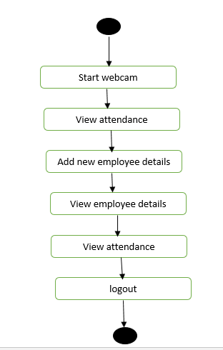

**Data flow :**

Data flow diagrams illustrate how data is processed by a system in terms of inputs and outputs. Data flow diagrams can be used to provide a clear representation of any business function. The technique starts with an overall picture of the business and continues by analyzing each of the functional areas of interest. This analysis can be carried out in precisely the level of detail required. The technique exploits a method called top-down expansion to conduct the analysis in a targeted way.

As the name suggests, Data Flow Diagram (DFD) is an illustration that explicates the passage of information in a process. A DFD can be easily drawn using simple symbols. Additionally, complicated processes can be easily automated by creating DFDs using easy-to-use, free downloadable diagramming tools. A DFD is a model for constructing and analyzing information processes. DFD illustrates the flow of information in a process depending upon the inputs and outputs. A DFD can also be referred to as a Process Model. A DFD demonstrates business or technical process with the support of the outside data saved, plus the data flowing from the process to another and the end results.

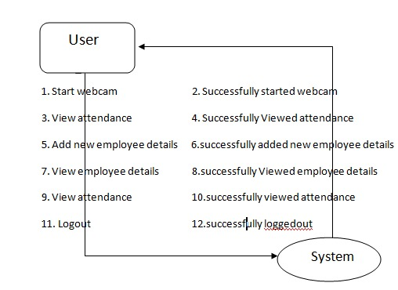

**5. IMPLEMETATION**

**5.1 Python**

Python is a general-purpose language. It has wide range of applications from Web development (like: Django and Bottle), scientific and mathematical computing (Orange, SymPy, NumPy) to desktop graphical user Interfaces (Pygame, Panda3D). The syntax of the language is clean and length of the code is relatively short. It's fun to work in Python because it allows you to think about the problem rather than focusing on the syntax.

**History of Python:**

Python is a fairly old language created by Guido Van Rossum. The design began in the late 1980s and was first released in February 1991.

**Why Python was created?**

In late 1980s, Guido Van Rossum was working on the Amoeba distributed operating system group. He wanted to use an interpreted language like ABC (ABC has simple easy-to-understand syntax) that could access the Amoeba system calls. So, he decided to create a language that was extensible. This led to design of a new language which was later named Python.

**Why the name Python?**

No. It wasn't named after a dangerous snake. Rossum was fan of a comedy series from late seventies. The name "Python" was adopted from the same series "Monty Python's Flying Circus".

**Features of Python:**

**A simple language which is easier to learn**

Python has a very simple and elegant syntax. It's much easier to read and write Python programs compared to other languages like: C++, Java, C#. Python makes programming fun and allows you to focus on the solution rather than syntax.

If you are a newbie, it's a great choice to start your journey with Python.

**Free and open-source**

You can freely use and distribute Python, even for commercial use. Not only can you use and distribute software’s written in it, you can even make changes to the Python's source code.

Python has a large community constantly improving it in each iteration.

**Portability**

You can move Python programs from one platform to another, and run it without any changes.

It runs seamlessly on almost all platforms including Windows, Mac OS X and Linux.

**Extensible and Embeddable**

Suppose an application requires high performance. You can easily combine pieces of C/C++ or other languages with Python code.

This will give your application high performance as well as scripting capabilities which other languages may not provide out of the box.

**A high-level, interpreted language**

Unlike C/C++, you don't have to worry about daunting tasks like memory management, garbage collection and so on.

Likewise, when you run Python code, it automatically converts your code to the language your computer understands. You don't need to worry about any lower-level operations.

**Large standard libraries to solve common tasks**

Python has a number of standard libraries which makes life of a programmer much easier since you don't have to write all the code yourself. For example: Need to connect MySQL database on a Web server? You can use MySQLdb library using import MySQLdb .

Standard libraries in Python are well tested and used by hundreds of people. So you can be sure that it won't break your application.

**Object-oriented**

Everything in Python is an object. Object oriented programming (OOP) helps you solve a complex problem intuitively.

With OOP, you are able to divide these complex problems into smaller sets by creating objects.

**Applications of Python:**

**1. Simple Elegant Syntax**

Programming in Python is fun. It's easier to understand and write Python code. Why? The syntax feels natural. Take this source code for an example:

a = 2

b = 3

sum = a + b

print(sum)

**2. Not overly strict**

You don't need to define the type of a variable in Python. Also, it's not necessary to add semicolon at the end of the statement.

Python enforces you to follow good practices (like proper indentation). These small things can make learning much easier for beginners.

**3. Expressiveness of the language**

Python allows you to write programs having greater functionality with fewer lines of code. Here's a link to the source code of Tic-tac-toe game with a graphical interface and a smart computer opponent in less than 500 lines of code. This is just an example. You will be amazed how much you can do with Python once you learn the basics.

**4. Great Community and Support**

Python has a large supporting community. There are numerous active forums online which can be handy if you are stuck.

**5.2 Sample Code:**

from django.shortcuts import render

from django.template import RequestContext

from django.contrib import messages

from django.http import HttpResponse

import os

from django.core.files.storage import FileSystemStorage

import pymysql

import datetime

import pyqrcode

import png

from pyqrcode import QRCode

global username

def test(request):

if request.method == 'GET':

return render(request, 'test.html', {})

def AdminLoginAction(request):

global username

if request.method == 'POST':

username = request.POST.get('t1', False)

password = request.POST.get('t2', False)

if username == 'admin' and password == 'admin':

context= {'data':'welcome '+username}

return render(request, 'AdminScreen.html', context)

else:

context= {'data':'login failed. Please retry'}

return render(request, 'AdminLogin.html', context)

def AdminLogin(request):

if request.method == 'GET':

return render(request, 'AdminLogin.html', {})

def UserLogin(request):

if request.method == 'GET':

return render(request, 'UserLogin.html', {})

def index(request):

if request.method == 'GET':

return render(request, 'index.html', {})

def AddEmp(request):

if request.method == 'GET':

return render(request, 'AddEmp.html', {})

def ViewEmpAttendanceAction(request):

if request.method == 'POST':

empid = request.POST.get('t1', False)

from_date = request.POST.get('t2', False)

to_date = request.POST.get('t3', False)

from_dd = str(datetime.datetime.strptime(from_date, "%d-%b-%Y").strftime("'%Y-%m-%d'"))

to_dd = str(datetime.datetime.strptime(to_date, "%d-%b-%Y").strftime("'%Y-%m-%d'"))

presence_days = 0

salary = 0

columns = ['Employee ID', 'Presence Date']

output = '<table border=1 align=center width=100%>'

font = '<font size="" color="black">'

output += "<tr>"

for i in range(len(columns)):

output += "<th>"+font+columns[i]+"</th>"

output += "</tr>"

con = pymysql.connect(host='127.0.0.1',port = 3306,user = 'root', password = 'root', database = 'qrattendance',charset='utf8')

with con:

cur = con.cursor()

cur.execute("select salary FROM addemp where emp_id='"+empid+"'")

rows = cur.fetchall()

for row in rows:

salary = row[0]

break

con = pymysql.connect(host='127.0.0.1',port = 3306,user = 'root', password = 'root', database = 'qrattendance',charset='utf8')

with con:

cur = con.cursor()

cur.execute("select * from attendance where emp_id='"+empid+"' and presence_days between "+from_dd+" and "+to_dd)

rows = cur.fetchall()

for row in rows:

presence_days = presence_days + 1

output += "<tr>"

output += "<td>"+font+str(row[0])+"</td>"

output += "<td>"+font+str(row[1])+"</td></tr>"

output += "<tr><td>"+font+"Number of Presence Days : "+str(presence_days)+"</font><td>"+font+"Total Salary = "+str(((salary/30) * presence_days))+"</td></tr>"

context= {'data': output}

return render(request, 'AdminScreen.html', context)

def ViewEmpAttendance(request):

if request.method == 'GET':

font = '<font size="" color="black">'

output = '<tr><td>'+font+'Choose&nbsp;Employee&nbsp;ID</td><td><select name="t1">'

con = pymysql.connect(host='127.0.0.1',port = 3306,user = 'root', password = 'root', database = 'qrattendance',charset='utf8')

with con:

cur = con.cursor()

cur.execute("select emp_id FROM addemp")

rows = cur.fetchall()

for row in rows:

output += '<option value="'+row[0]+'">'+row[0]+'</option>'

output += "</select></td></tr>"

context= {'data1': output}

return render(request, 'ViewEmpAttendance.html', context)

def ViewAttendance(request):

if request.method == 'GET':

return render(request, 'ViewAttendance.html', {})

def ViewAttendanceAction(request):

if request.method == 'POST':

global username

empid = username

from_date = request.POST.get('t1', False)

to_date = request.POST.get('t2', False)

from_dd = str(datetime.datetime.strptime(from_date, "%d-%b-%Y").strftime("'%Y-%m-%d'"))

to_dd = str(datetime.datetime.strptime(to_date, "%d-%b-%Y").strftime("'%Y-%m-%d'"))

presence_days = 0

salary = 0

columns = ['Employee ID', 'Presence Date']

output = '<table border=1 align=center width=100%>'

font = '<font size="" color="black">'

output += "<tr>"

for i in range(len(columns)):

output += "<th>"+font+columns[i]+"</th>"

output += "</tr>"

con = pymysql.connect(host='127.0.0.1',port = 3306,user = 'root', password = 'root', database = 'qrattendance',charset='utf8')

with con:

cur = con.cursor()

cur.execute("select salary FROM addemp where emp_id='"+empid+"'")

rows = cur.fetchall()

for row in rows:

salary = row[0]

break

con = pymysql.connect(host='127.0.0.1',port = 3306,user = 'root', password = 'root', database = 'qrattendance',charset='utf8')

with con:

cur = con.cursor()

cur.execute("select * from attendance where emp_id='"+empid+"' and presence_days between "+from_dd+" and "+to_dd)

rows = cur.fetchall()

for row in rows:

presence_days = presence_days + 1

output += "<tr>"

output += "<td>"+font+str(row[0])+"</td>"

output += "<td>"+font+str(row[1])+"</td></tr>"

output += "<tr><td>"+font+"Number of Presence Days : "+str(presence_days)+"</font><td>"+font+"Total Salary = "+str(((salary/30) * presence_days))+"</td></tr>"

context= {'data': output}

return render(request, 'UserScreen.html', context)

def ViewEmp(request):

if request.method == 'GET':

columns = ['Employee ID', 'Employee Name', 'Contact No', 'Email ID', 'Gender', 'Address', 'Designation', 'Salary']

output = '<table border=1 align=center width=100%>'

font = '<font size="" color="black">'

output += "<tr>"

for i in range(len(columns)):

output += "<th>"+font+columns[i]+"</th>"

output += "</tr>"

con = pymysql.connect(host='127.0.0.1',port = 3306,user = 'root', password = 'root', database = 'qrattendance',charset='utf8')

with con:

cur = con.cursor()

cur.execute("select * FROM addemp")

rows = cur.fetchall()

for row in rows:

output += "<tr>"

output += "<td>"+font+str(row[0])+"</td>"

output += "<td>"+font+str(row[1])+"</td>"

output += "<td>"+font+str(row[2])+"</td>"

output += "<td>"+font+str(row[3])+"</td>"

output += "<td>"+font+str(row[4])+"</td>"

output += "<td>"+font+str(row[5])+"</td>"

output += "<td>"+font+str(row[6])+"</td>"

output += "<td>"+font+str(row[7])+"</td></tr>"

context= {'data': output}

return render(request, 'AdminScreen.html', context)

def UserLoginAction(request):

global username

if request.method == 'POST':

username = request.POST.get('t1', False)

index = 0

emp_name = None

con = pymysql.connect(host='127.0.0.1',port = 3306,user = 'root', password = 'root', database = 'qrattendance',charset='utf8')

with con:

cur = con.cursor()

cur.execute("select emp_id, emp_name FROM addemp")

rows = cur.fetchall()

for row in rows:

if row[0] == username:

emp_name = row[1]

index = 1

break

if index == 1:

context= {'data':'welcome '+emp_name}

return render(request, 'UserScreen.html', context)

else:

context= {'data':'login failed. Please retry'}

return render(request, 'UserLogin.html', context)

def DownloadAction(request):

if request.method == 'POST':

global username

print("===="+username)

infile = open("AttendanceApp/static/qrcodes/"+username+".png", 'rb')

data = infile.read()

infile.close()

response = HttpResponse(data, content_type='image/png')

response['Content-Disposition'] = 'attachment; filename=%s' % username+".png"

return response

def AddEmpAction(request):

if request.method == 'POST':

global username

empid = request.POST.get('t1', False)

empname = request.POST.get('t2', False)

contact = request.POST.get('t3', False)

gender = request.POST.get('t4', False)

email = request.POST.get('t5', False)

address = request.POST.get('t6', False)

designation = request.POST.get('t7', False)

salary = request.POST.get('t8', False)

output = "none"

con = pymysql.connect(host='127.0.0.1',port = 3306,user = 'root', password = 'root', database = 'qrattendance',charset='utf8')

with con:

cur = con.cursor()

cur.execute("select emp_id FROM addemp")

rows = cur.fetchall()

for row in rows:

if row[0] == empid:

output = empid+" employee already exists"

break

if output == 'none':

db_connection = pymysql.connect(host='127.0.0.1',port = 3306,user = 'root', password = 'root', database = 'qrattendance',charset='utf8')

db_cursor = db_connection.cursor()

student_sql_query = "INSERT INTO addemp(emp_id,emp_name,contact_no,gender,email,address,designation,salary) VALUES('"+empid+"','"+empname+"','"+contact+"','"+gender+"','"+email+"','"+address+"','"+designation+"','"+salary+"')"

db_cursor.execute(student_sql_query)

db_connection.commit()

url = pyqrcode.create(empid)

url.png('AttendanceApp/static/qrcodes/'+empid+'.png', scale = 6)

username = empid

print(db_cursor.rowcount, "Record Inserted")

if db_cursor.rowcount == 1:

output = 'New Employee Details added with Employee ID : '+empid

context= {'data':output}

return render(request, 'Download.html', context)

**6. TESTING:**

**Implementation and Testing:**

Implementation is one of the most important tasks in project is the phase in which one has to be cautions because all the efforts undertaken during the project will be very interactive. Implementation is the most crucial stage in achieving successful system and giving the users confidence that the new system is workable and effective. Each program is tested individually at the time of development using the sample data and has verified that these programs link together in the way specified in the program specification. The computer system and its environment are tested to the satisfaction of the user.

## Implementation

## The implementation phase is less creative than system design. It is primarily concerned with user training, and file conversion. The system may be requiring extensive user training. The initial parameters of the system should be modifies as a result of a programming. A simple operating procedure is provided so that the user can understand the different functions clearly and quickly. The different reports can be obtained either on the inkjet or dot matrix printer, which is available at the disposal of the user. The proposed system is very easy to implement. In general implementation is used to mean the process of converting a new or revised system design into an operational one.

## Testing

Testing is the process where the test data is prepared and is used for testing the modules individually and later the validation given for the fields. Then the system testing takes place which makes sure that all components of the system property functions as a unit. The test data should be chosen such that it passed through all possible condition. Actually testing is the state of implementation which aimed at ensuring that the system works accurately and efficiently before the actual operation commence. The following is the description of the testing strategies, which were carried out during the testing period.

### System Testing

Testing has become an integral part of any system or project especially in the field of information technology. The importance of testing is a method of justifying, if one is ready to move further, be it to be check if one is capable to with stand the rigors of a particular situation cannot be underplayed and that is why testing before development is so critical. When the software is developed before it is given to user to use the software must be tested whether it is solving the purpose for which it is developed. This testing involves various types through which one can ensure the software is reliable. The program was tested logically and pattern of execution of the program for a set of data are repeated. Thus the code was exhaustively checked for all possible correct data and the outcomes were also checked.

**Module Testing**

To locate errors, each module is tested individually. This enables us to detect error and correct it without affecting any other modules. Whenever the program is not satisfying the required function, it must be corrected to get the required result. Thus all the modules are individually tested from bottom up starting with the smallest and lowest modules and proceeding to the next level. Each module in the system is tested separately. For example the job classification module is tested separately. This module is tested with different job and its approximate execution time and the result of the test is compared with the results that are prepared manually. The comparison shows that the results proposed system works efficiently than the existing system. Each module in the system is tested separately. In this system the resource classification and job scheduling modules are tested separately and their corresponding results are obtained which reduces the process waiting time.

**Integration Testing**

After the module testing, the integration testing is applied. When linking the modules there may be chance for errors to occur, these errors are corrected by using this testing. In this system all modules are connected and tested. The testing results are very correct. Thus the mapping of jobs with resources is done correctly by the system.

**Acceptance Testing**

When that user fined no major problems with its accuracy, the system passers through a final acceptance test. This test confirms that the system needs the original goals, objectives and requirements established during analysis without actual execution which elimination wastage of time and money acceptance tests on the shoulders of users and management, it is finally acceptable and ready for the operation.

|  |  |  |  |  |  |  |  |  |
| --- | --- | --- | --- | --- | --- | --- | --- | --- |
| **Test Case Id** | **Test Case Name** | **Test Case Desc.** | **Test Steps** | | | | **Test Case Status** | **Test Priority** |
| **Step** | **Expected** | | **Actual** |
| 01 | Admin module | Verify  Admin moduleor not | If Admin modulemay not upload | we cannot do any further operations | we can do further operations | | High | High |
| 02 | Employee Login Module | Verify Employee Login Module or not | If Employee Login Module not be Done | we cannot do any further operations | we can do further operations | | High | High |
| 03 | QR CODE WEBCAM SCANNER | Verify QR CODE WEBCAM SCANNER or not | If QR CODE WEBCAM SCANNER may not be done | we cannot do any further operations | we can do further operations | | High | High |

**7. SCREENSHOTS:**

All details will be stored in MYSQL database and to run project install MYSQL database and PYTHON 3.7 and then copy content from ‘DB.txt’ file and then paste in MYSQL console to create database.

Now double click on ‘run.bat’ file to start python web server and get below screen

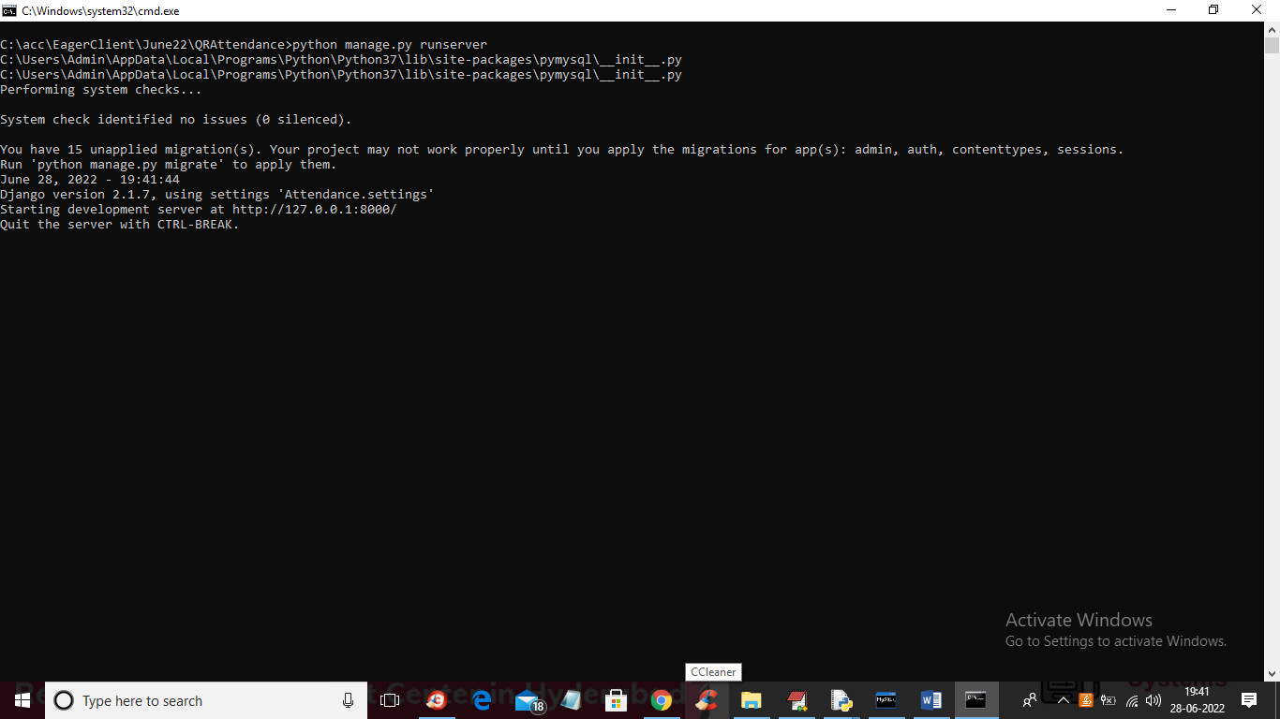

In above screen python web server started and now open browser and enter URL as ‘http://127.0.0.1:8000/index.html’ and press enter key to get below page

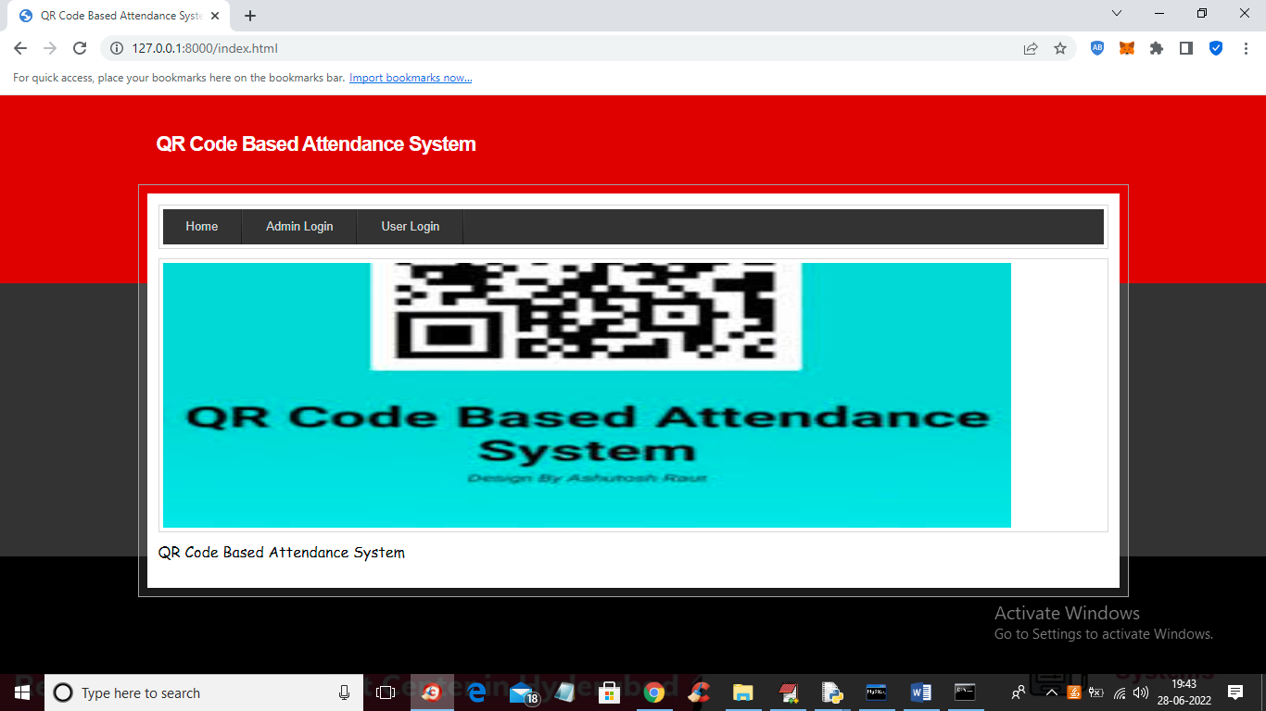

In above screen click on ‘Admin Login’ link to get below login screen

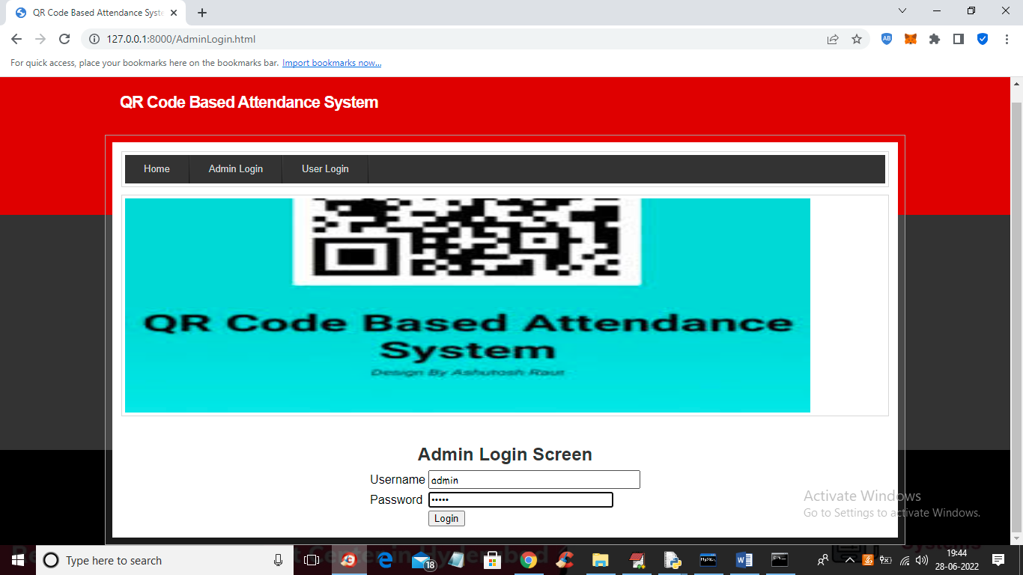

In above screen admin is login and after login will get below screen

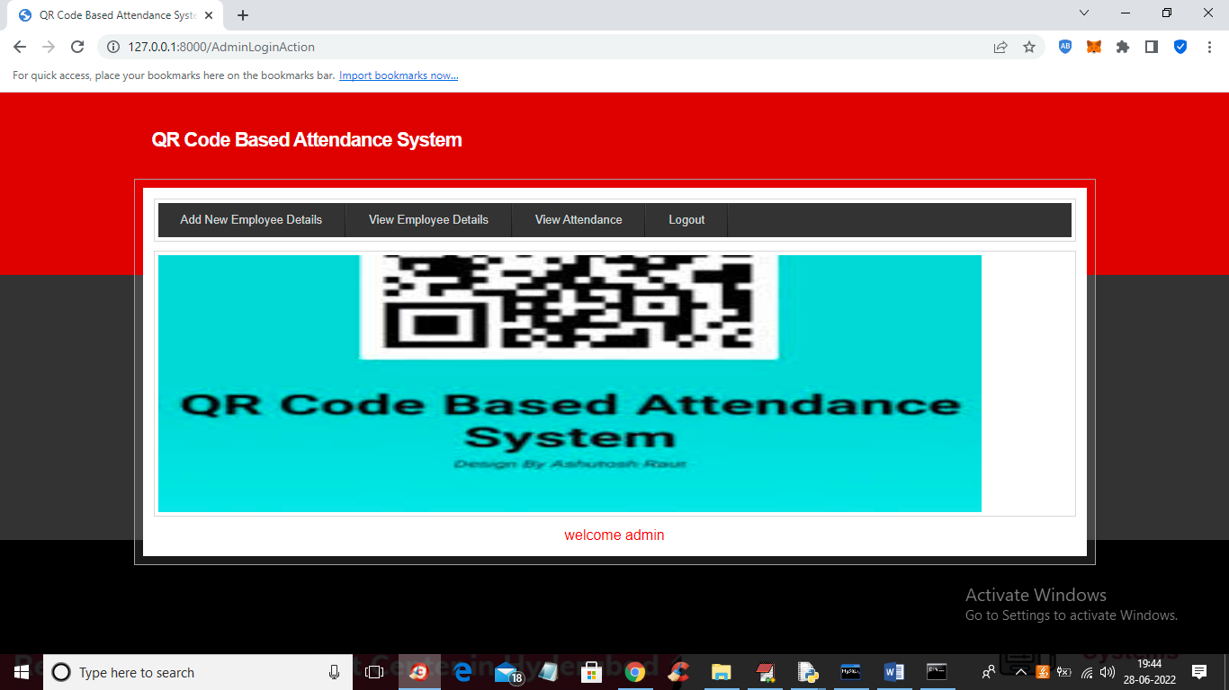

In above screen admin can click on ‘Add New Employee Details’ link to get below screen to add employee details

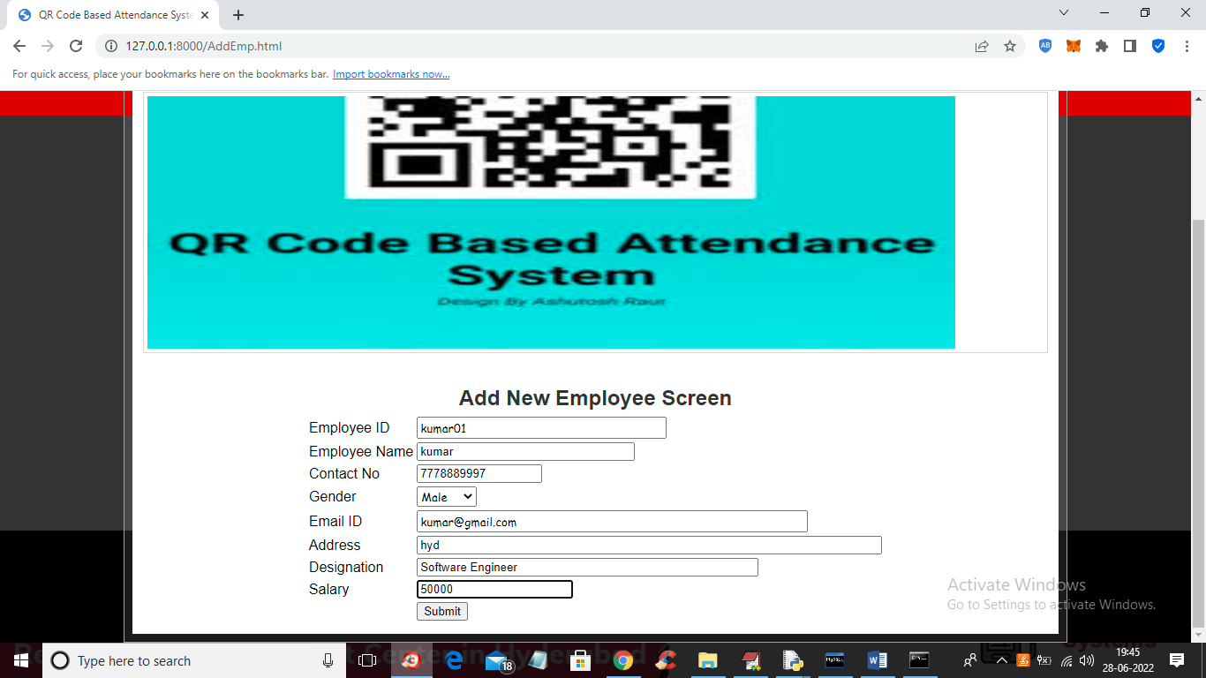

In above screen admin is adding NEW Employee Details and then press button to get below screen

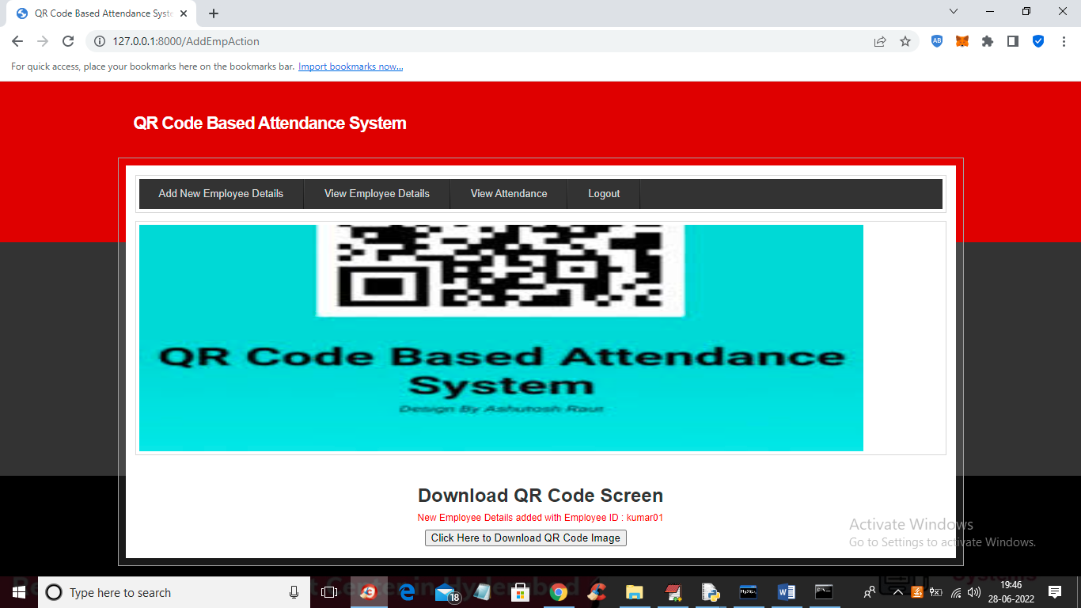

In above screen employee details added and now click on ‘Click Here to Download QR Code Image’ button to download QR image and get below output

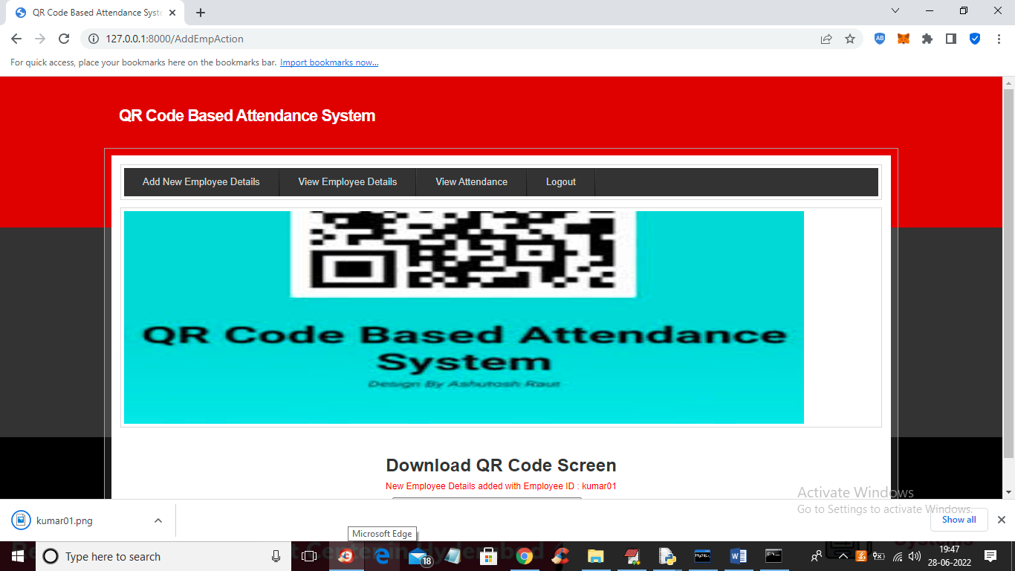

In above screen in browser status bar we can see QR image is downloaded and admin will give this image to employee and he can saved this image in mobile and then can show this image from his mobile to WEBCAM to mark his attendance and now open that image and view QR CODE like below screen

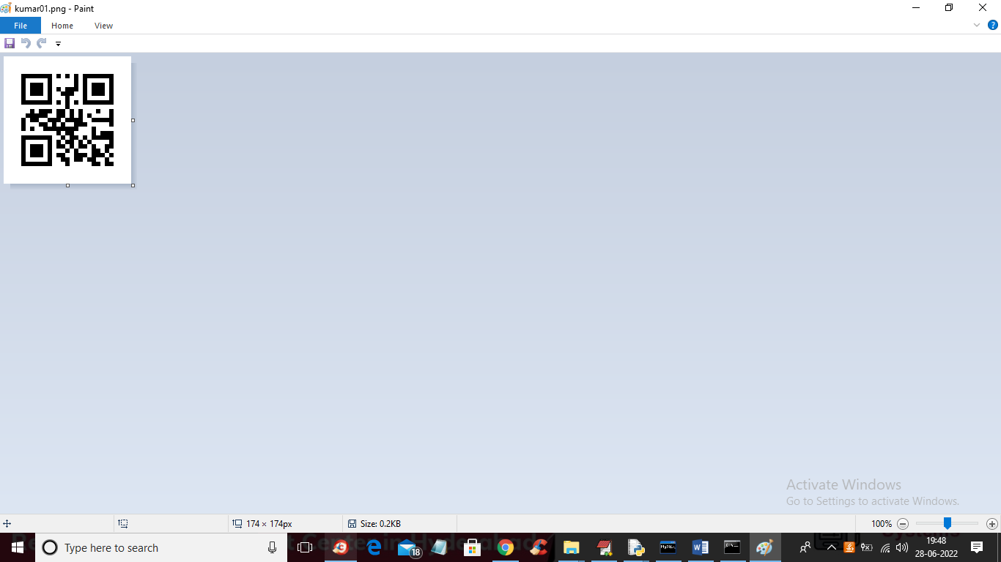

In above screen we can see QR code and now in application click on ‘View Employee Details’ link to get below details

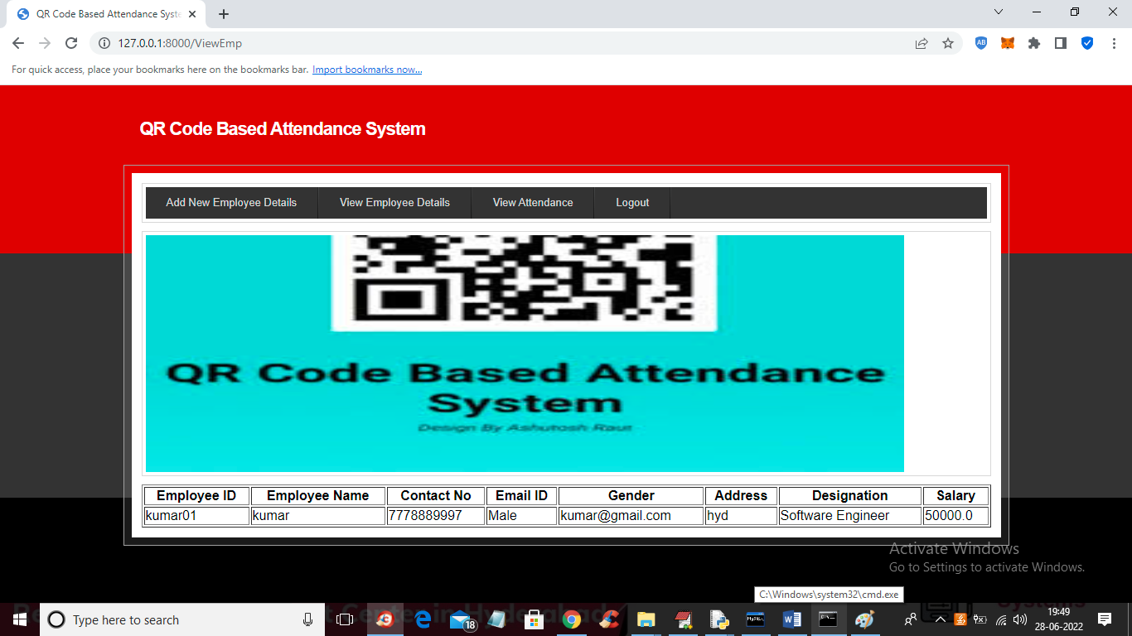

In above screen admin can view all employee details and now to mark attendance double click on ‘RunWebCam.bat’ file to get below screen

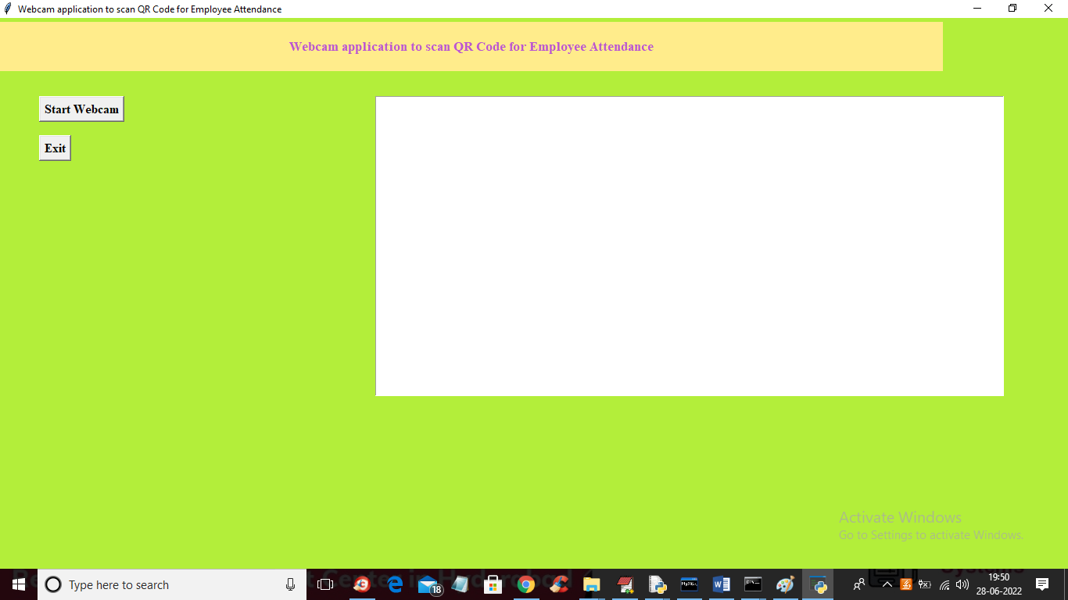

In above screen click on ‘Start Webcam’ button to start web cam and get below screen

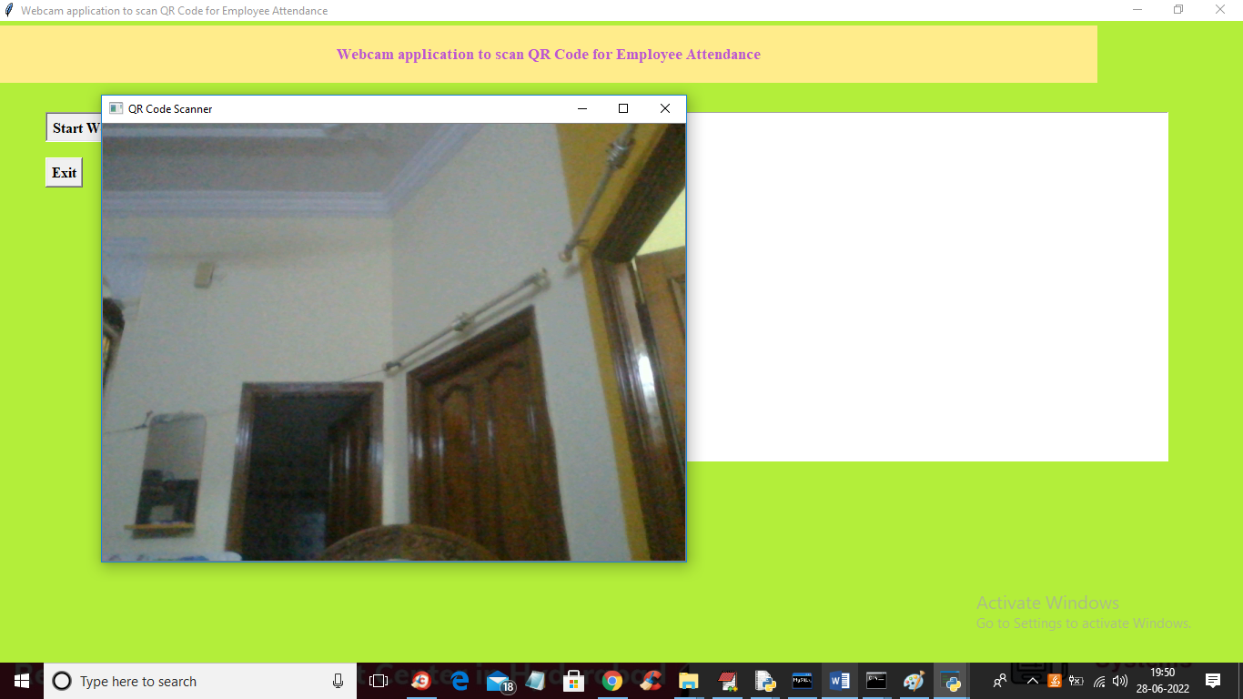

In above screen webcam started and now employee has to show QRCODE from his mobile like below screen and once QR code detected then system will mark attendance

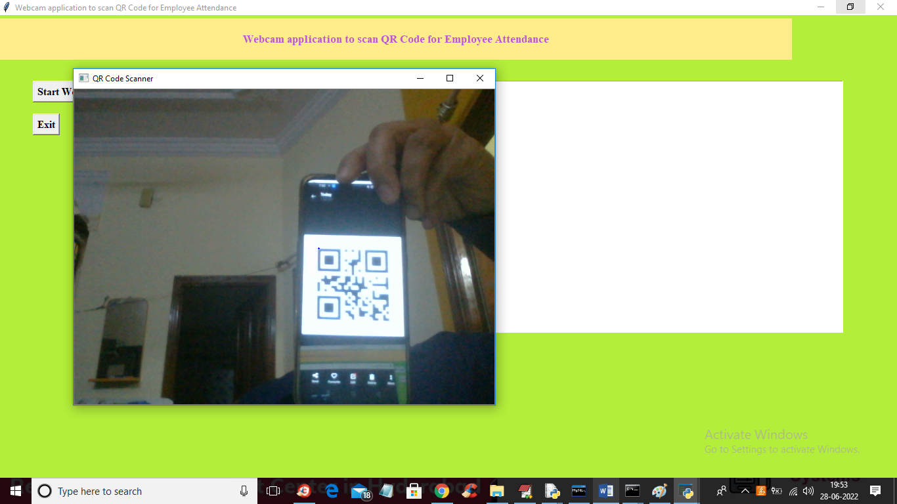

In above screen to webcam I am showing QRCODE and once detected then will get below screen

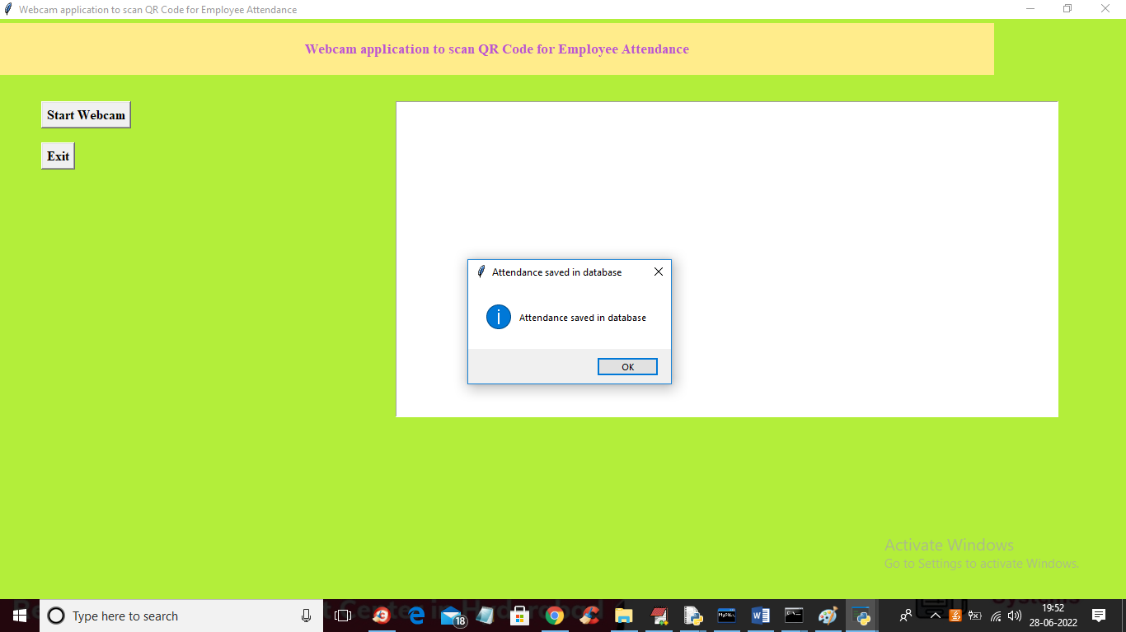

In above screen we got dialog box saying ‘attendance saved in database’ and each employee each day only one time webcam will scan his QRCODE and if he want again then delete all rows from database. Now go to previous application and then click on ‘View Attendance’ link like in below screen

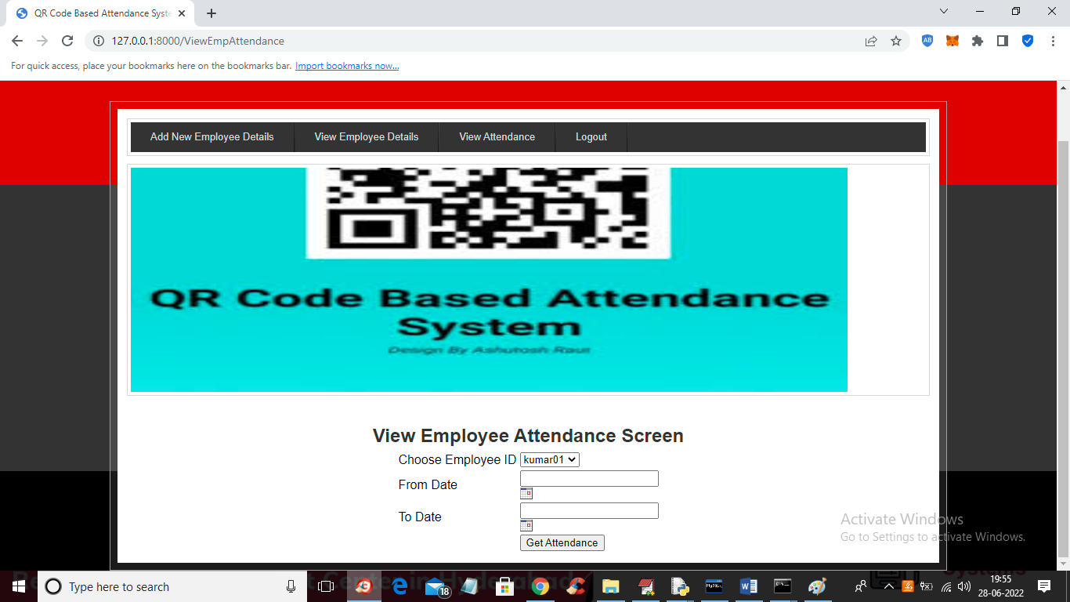

In above view attendance screen admin can view all employee names in drop down box and he can select desired employee name and then choose start and end date like below screen

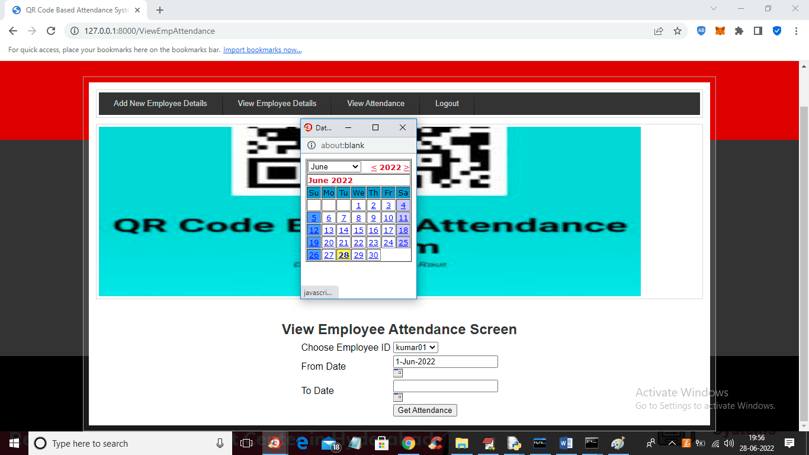

In above screen admin selected employee id and then select start and end date and then press ‘get Attendance’ button to get below screen

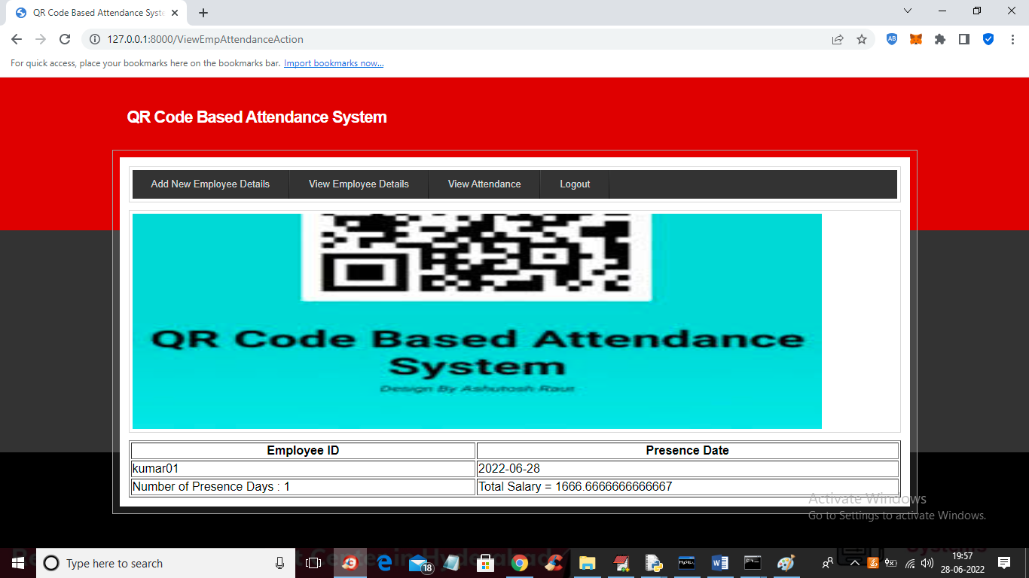

In above screen in first column we can see employee ID and in second column we can see date on which he was present and in last column we can see his payable salary by calculating all present days. Now logout and login as employee

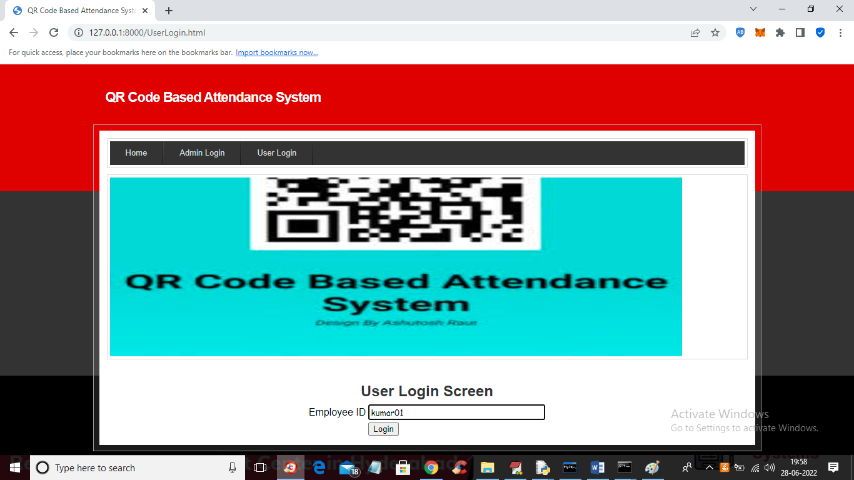

In above screen employee can login by using his ID and then press button to get below screen

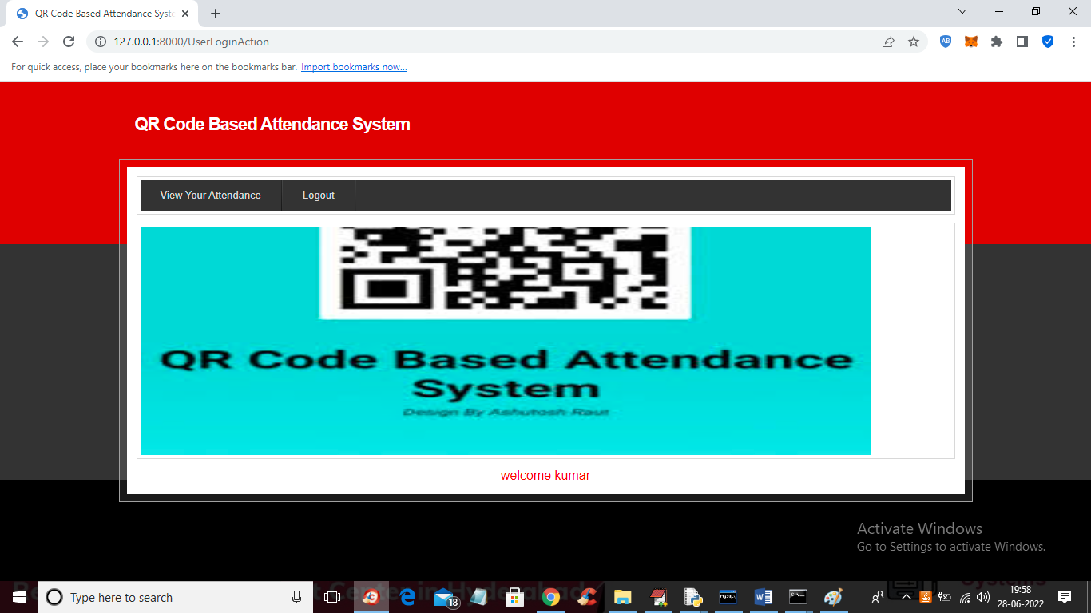

In above screen employee can click on ‘View Your Attendance’ link to get below screen

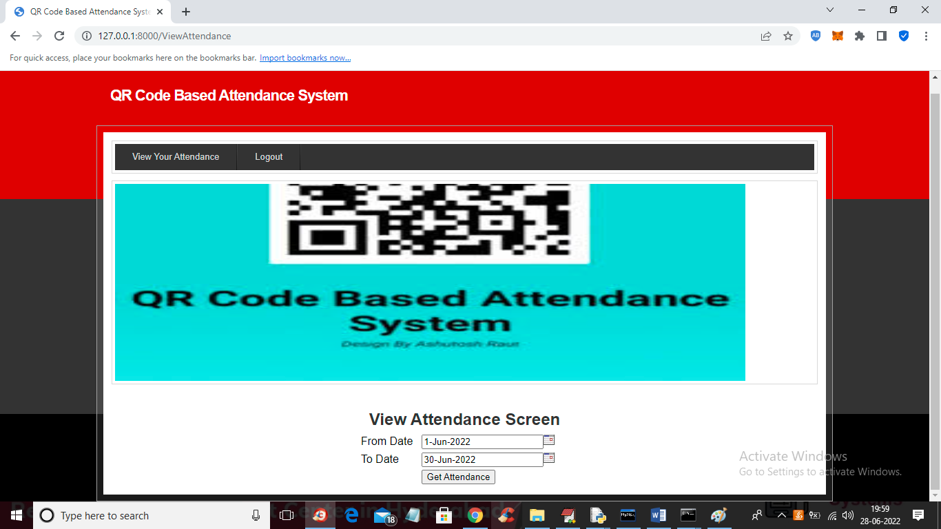

In above screen employee can select start and end date and then press button to view his attendance for selected days

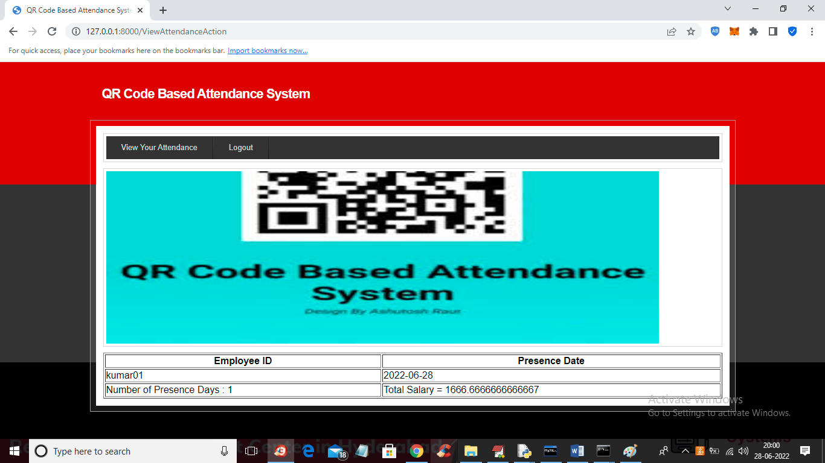

In above screen employee can view all present days date and current payable salary.

Similarly you can add any number of employees and go for attendance and view it

**8. CONCLUSION:**

These days it is required to keep up with the latest technologies, especially in the field of education. Educational institutions have been looking for ways to enhance the educational process using the latest technologies. Seeing as everything moves towards digitalization, we think that this system is pretty much necessary for the University. In this paper, we have described a proposed system that incorporates QR codes and devices connected to internet in taking student attendance. This study shows that the QR code, a multi-faceted and popular feature of smart devices, can be used as an efficient method of recording attendance, replacing the old, traditional way of calling name lists in class. This system was developed after reviewing and analyzing the existing manual system and an analysis of the systems used by other Universities. This affordable QR code-based attendance system enables lecturers to speed up the process of recording attendance, especially in a large classroom and would save them valuable teaching time. The proposed system provides better security than the traditional methods, including eliminating chances of students signing up for others who may not be present. Even though similar platforms are already developed, we believe that the proposed platform will be more attractive for several reasons: It has a great advantage, among all types of code scanning technology; the QR Code attendance system is the most accurate and efficient method of maintaining attendance in a database and controlling it from any intelligent device rather than wasting paper. The acceptance of QR code by students and educators is critical to the successful implementation of this technology. Therefore, it is important to understand the factors that affect student and lecturer intentions to use the QR code for this purpose.

**9. REFERENCES:**

[1]. Punch Card, available at: https://www.computerhope.com/jargon/p/punccard.htm, last accessed: 03 Jan 2020

[2]. Punch card attendance system, available at: http://www.bioenabletech.com/punch-card-attendance-system.html, last accessed: 03 Jan 2020

[3]. M. A. Abas, T. B. Tuck, and M. Dahlui, “Attendance Management System (AMS) with fast track analysis,” in 2014, International Conference on Computer, Control, Informatics and Its Applications (IC3INA), 2014, pp. 35–40.

[4]. T. J. Zhi, Z. Ibrahim, and H. Aris, “Effective and efficient attendance tracking system using secret code,” in Proceedings of the 6th International Conference on Information Technology and Multimedia, 2014, pp. 108– 112.

[5]. S. K. Jain, U. Joshi, and B. K. Sharma, “Attendance Management System,” Masters Project Report, Rajasthan Technical University, Kota.

[6]. A. Manori, N. Devnath, N. Pasi, and V. Kumar, “QR Code Based Smart Attendance System”, Int. J. Smart Bus. Technol., vol. 5, no. 1, pp. 1–10, Jul. 2017.

[7]. FadiMasalha and NaelHirzallah, “A Students Attendance System Using QR Code”, International Journal of Advanced Computer Science and Applications vol. 5, no.3, pp. 75-79, Jan. 2014.

[8]. What is a QR Code?, available at: https://www.the-qrcode-generator.com/whats-a-qr-code,last accessed: 07 Jan 2020